Lab 1:
- Check if your processor supports Intel/AMD virtualization technology. Enable Intel virtualization technology in BIOS if possible.
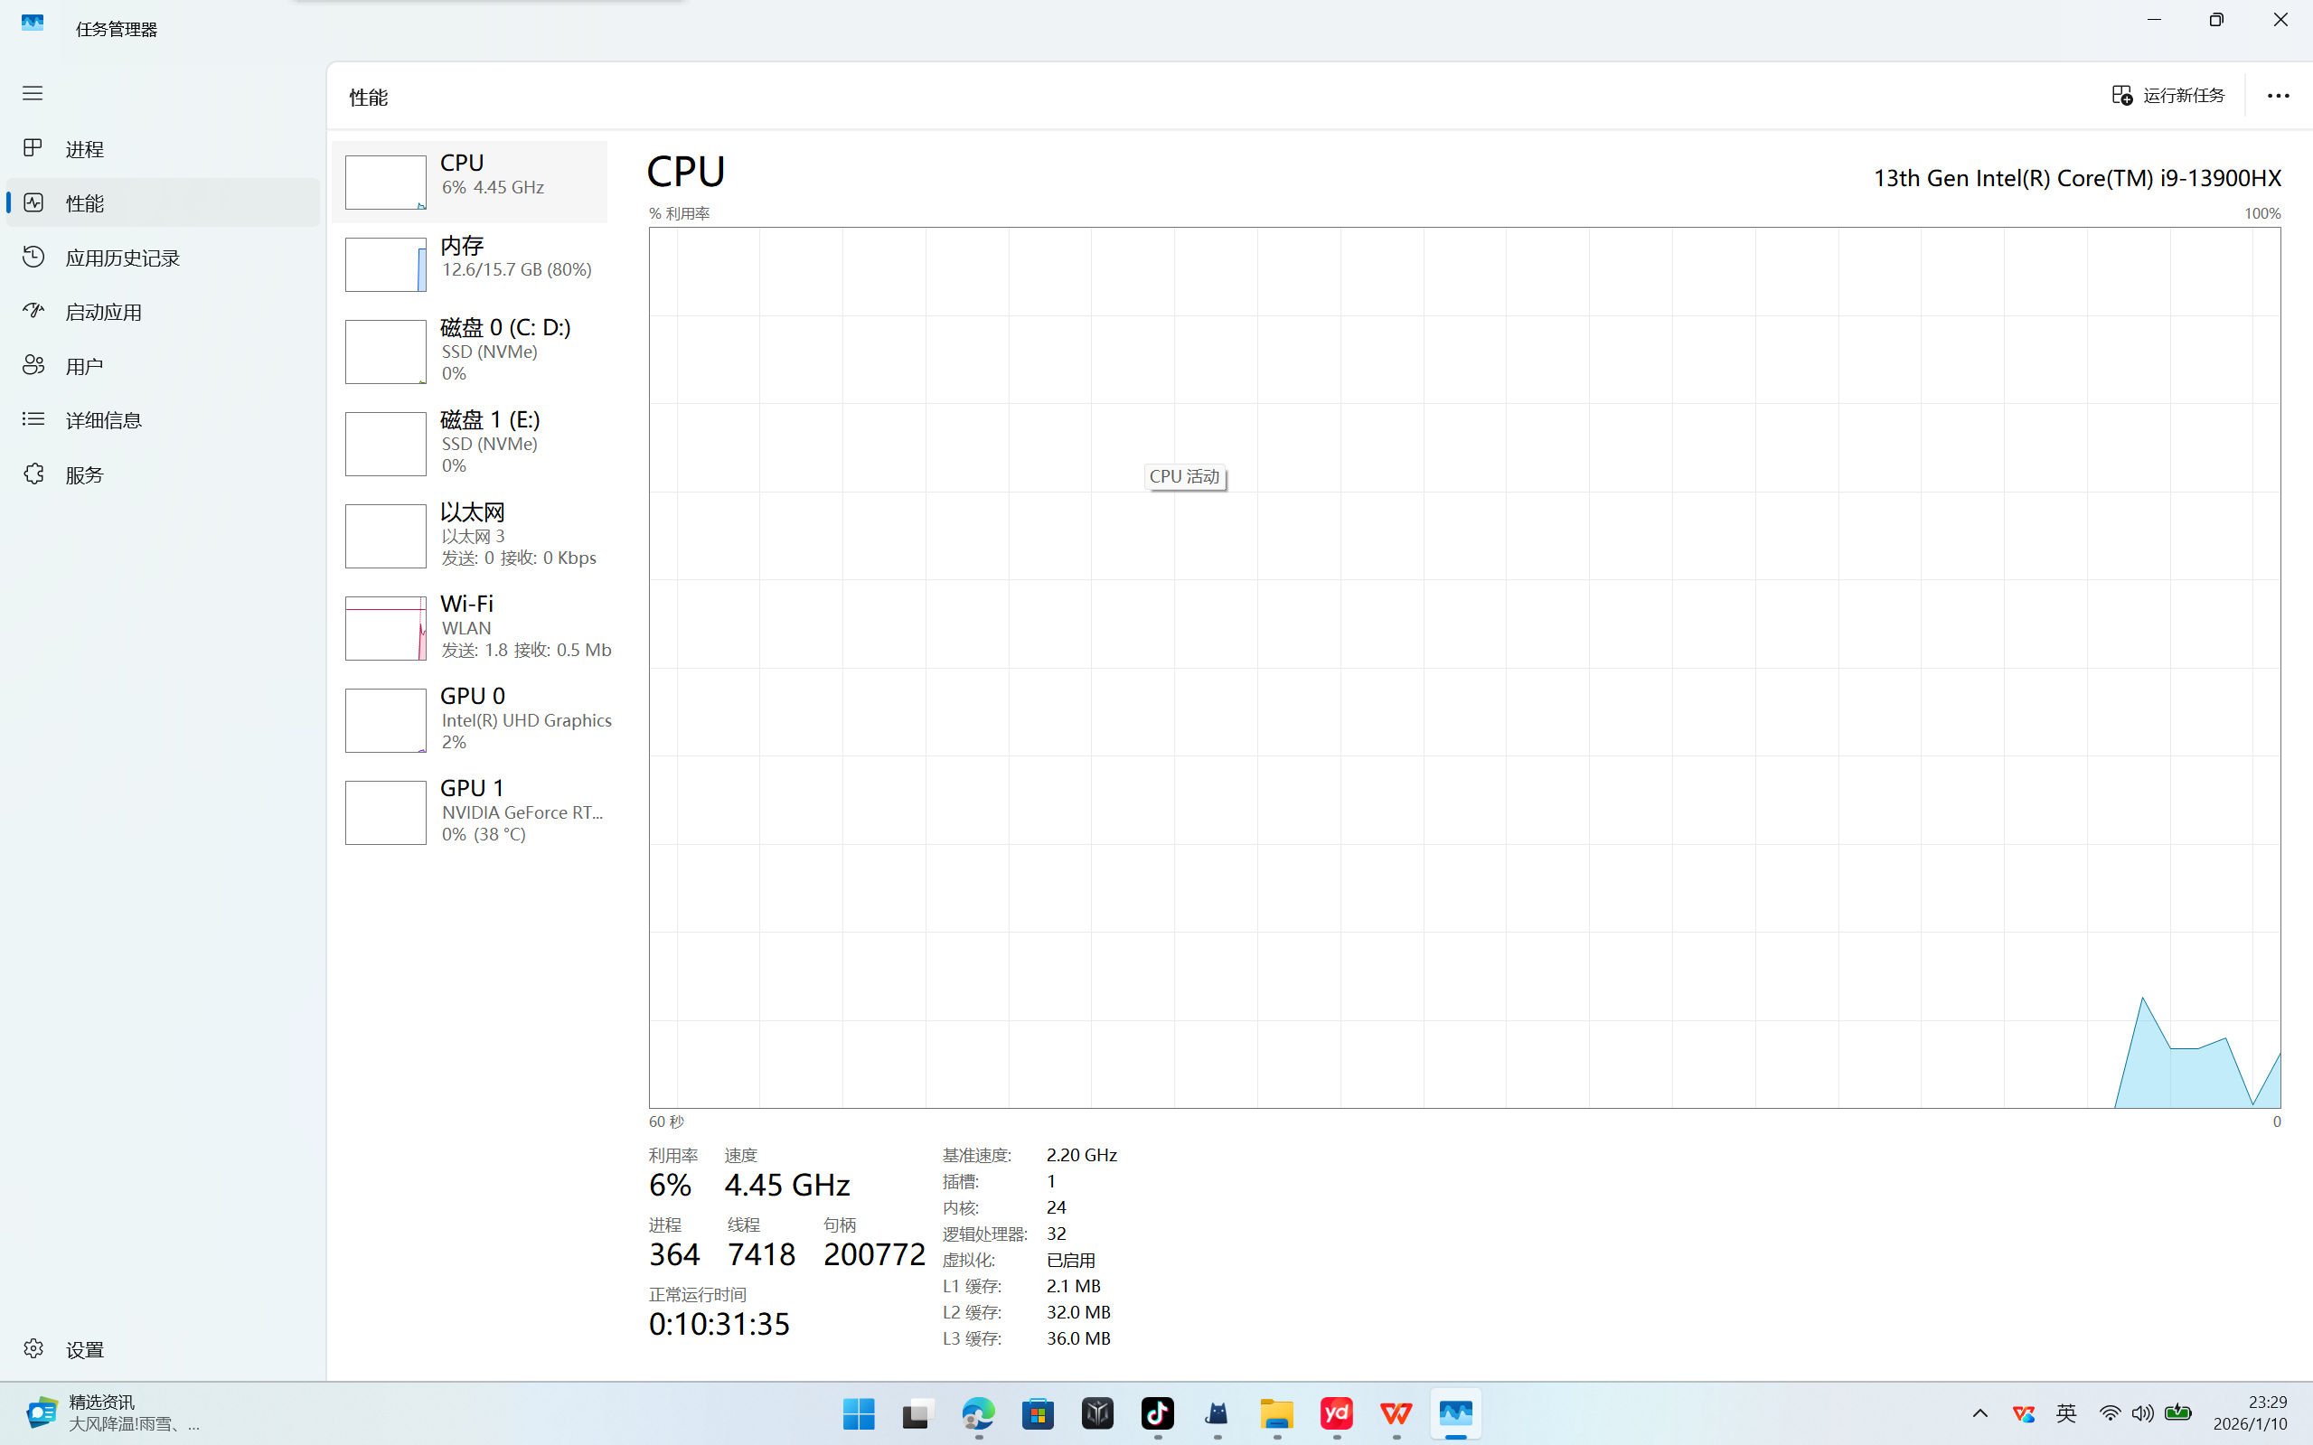
2. The cloud is almost everywhere in our lives now. What do you think are the fundamental reasons behind its success? Name three pros and three cons of cloud.
Fundamental reasons: Scalability, cost-effectiveness, accessibility, and the shift to remote/digital services.
Three pros:
Cost savings (pay-as-you-go model).
High availability and reliability.
Easy scalability and flexibility.
Three cons:
Dependency on internet connectivity.
Security and privacy concerns.
Potential for unexpected costs (cost overruns).
3. What is the primary function of a hypervisor in virtualization?
The primary function of a hypervisor is to create and manage virtual machines (VMs) by abstracting and partitioning physical hardware resources so multiple VMs can run simultaneously on a single physical machine.
4. What is a virtual machine (VM)?
A virtual machine (VM) is a software-based emulation of a physical computer that runs an operating system and applications as if it were a separate physical machine.

5. What are the benefits of using virtual machines?
Resource efficiency (multiple VMs on one physical host).
Isolation (VMs do not interfere with each other).
Portability (easy to move, copy, or migrate).
Snapshots and backup capabilities.
Testing and development flexibility.
6. List five use cases of virtual machines.
Running multiple operating systems on one machine (e.g., Linux on Windows).
Software testing and development in isolated environments.
Server consolidation in data centers.
Disaster recovery and backup solutions.
Running legacy applications on older OS versions.
7. In virtualization, what is the guest operating system?
a) The main operating system running on the physical machine
b) The operating system installed on a virtual machine√
c) The operating system running on a remote server
d) The operating system running on a mobile device

8. What does virtual machine isolation mean?
a) Virtual machines can communicate directly with the physical hardware.
b) Virtual machines share the same resources and cannot be isolated.
c) Virtual machines run independently and are isolated from each other and the host system.√
d) Virtual machines can only be accessed locally.

9. What is the benefit of virtual machine portability?
a) It allows virtual machines to communicate with each other easily.
b) It ensures faster boot times for virtual machines.
c) It allows virtual machines to be moved between different physical machines with compatible hypervisors.√
d) It reduces the need for hardware virtualization.

- What is the purpose of cloning a virtual machine?
Cloning a virtual machine creates an exact copy of an existing VM, which is useful for rapid deployment, testing, backup, or creating multiple identical environments without manual setup.

